Performance differences between different arrays
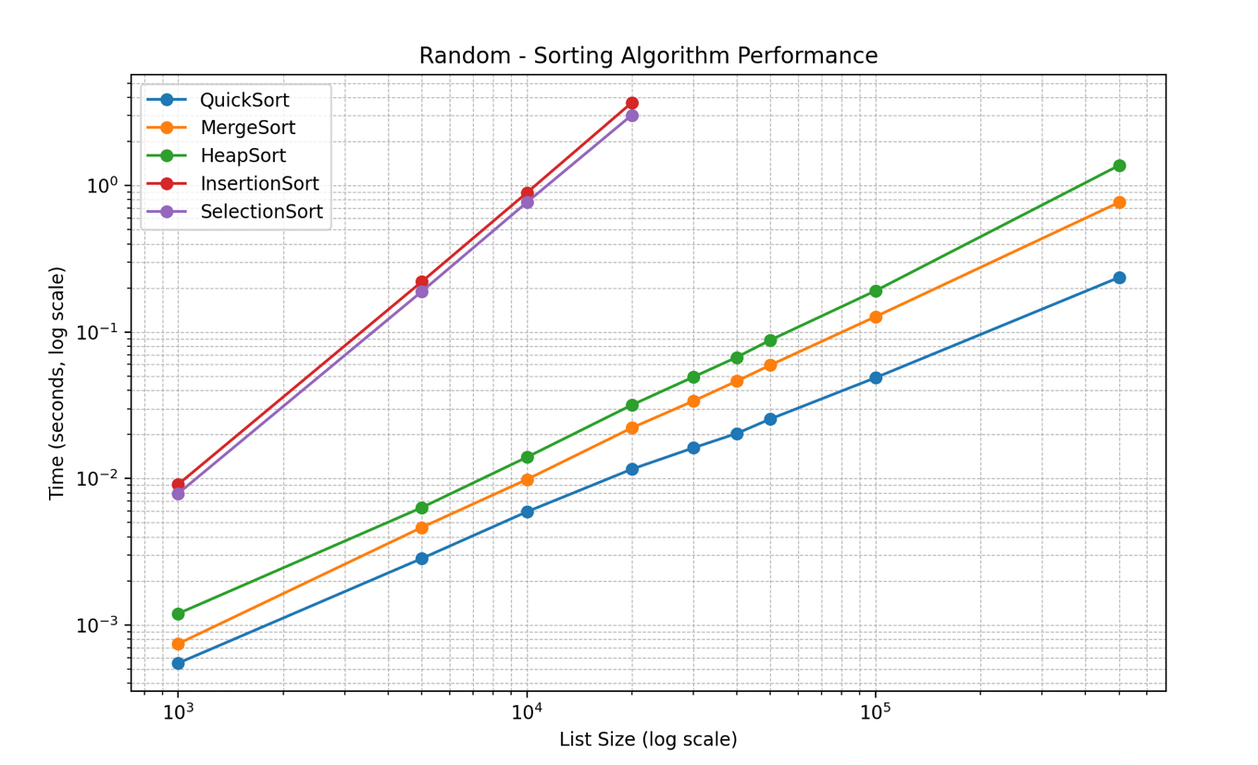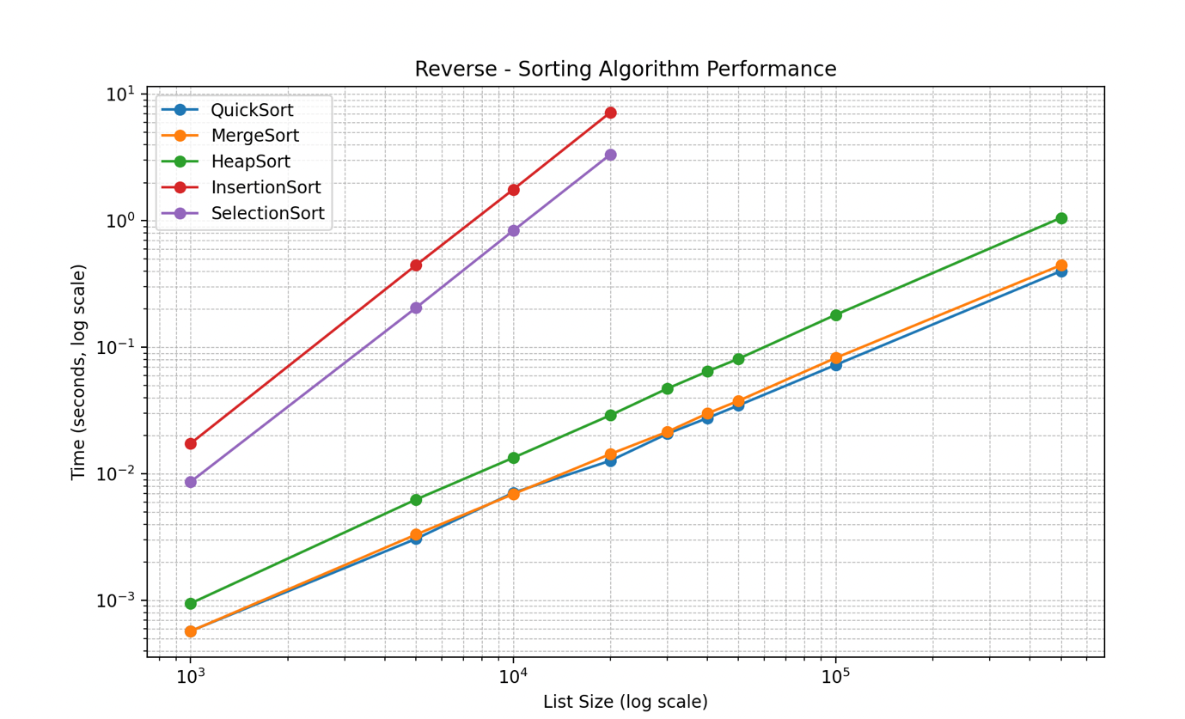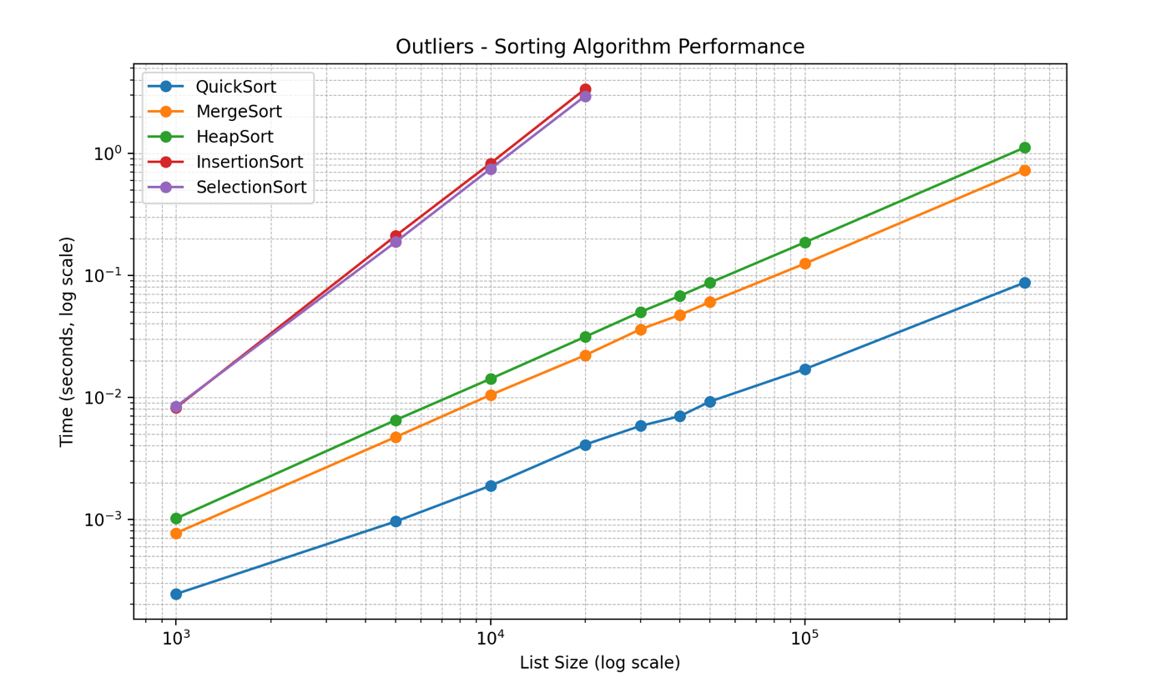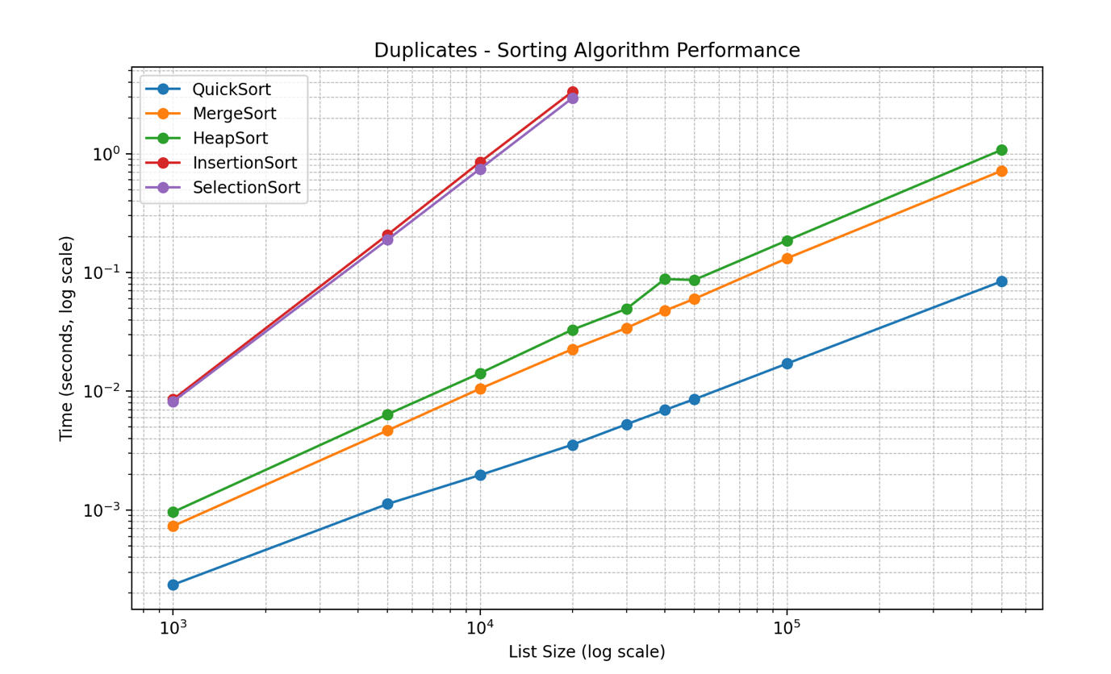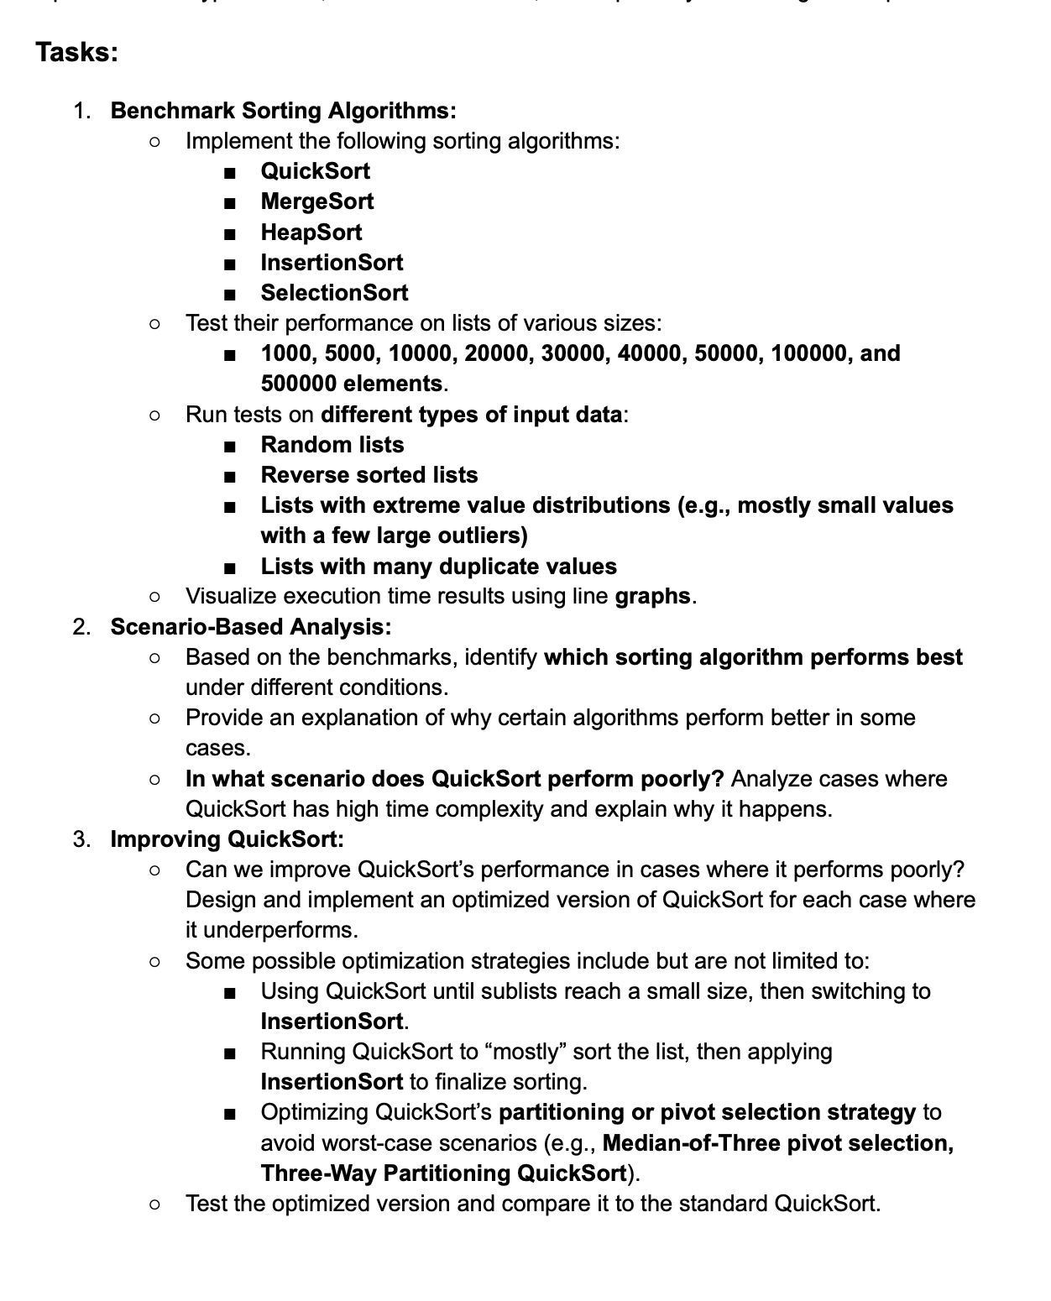
2. Scenario Based analysis.
Q1. Based on the benchmarks, identify which sorting algorithm performs best under different conditions.
It seems like quicksort consistently performs the best under all conditions tested in this benchmark, though was slightly closer with merge sort when testing on reverse sorted lists. Mergesort is more stable however as it maintains the order of equal elements, so mergeSort may be preferable under certain circumstances where stable sorting is required.

Q2. Provide an explanation of why certain algorithms perform better in some cases.
On the outliers and duplicates, quicksort performed extremely well compared to its other O(n log n) counterparts. This could be because random pivot selection often splits the arrays into relatively balanced sub-arrays, and the three-way-partitioning approach on my algorithm helps to group duplicates quickly and reduces extra recursion. The quick, merge, and heap sort are all algorithms with a $O(n log n)$ time complexity and thus run much faster than insertion and selection sort which run in $O(n^{2}$) time complexity and are much slower.
Selection sort does perform well in certain use cases for example, when finding the lowest $k$ elements in an array. This is because selection sort always finds the minimum in each pass in $O(n)$ time. This means that finding the lowest $k$ elements, it will take $O(kn)$ time, rather than needing to sort the entire array like the other algorithms. This can be faster then $O\left(n\log\left(n\right)\right)$ algorithms, depending on how large of a number $k$ is.
Even though merge and heap sort guarantee $O(n\log{n)}$ time complexity, while quicksort is $O(n\log{n)}$ at its best case and $O(n^{2})$ at its worst case. Quicksort still remains faster in practice because heapsort has worse cache efficiency, more swaps and more overhead per operation, and merge sort requires more data movement, and compares elements in already sorted sub arrays.
Q3. In what scenario does quicksort perform poorly. Analyse cases where Quicksort has high time complexity and explain why it happens.
Quicksort performed most poorly on reverse sorted lists but still was slightly faster than all other sorting algorithms including merge sort. This may be simply due to suboptimal pivot selection; it was still the fastest algorithm in practice. In the absolute worst-case scenario where the pivot that is randomly selected is a minimum or maximum on every single iteration, this would near $O(n^{2})$ time complexity.

3. Improving Quick Sort
1. Can we improve quicksort’s performance where it performs poorly?
Some limitations of my current method include:
The possibility of poor pivot selection as it’s randomly chosen and can lead to $O\left(n^{2}\right)$ time complexity. A solution for this is to use a median of three pivot selection which would decrease the possibility of picking a bad pivot. Recursive calls on very small subarrays can add unnecessary overhead. This can be limitated by switching to insertion sort for subarrays less then 10.
Implementing a hybrid quicksort version which uses a randomly selected median of 3 pivot and insertion sort for array sizes 10 or below. The following has been benchmarked.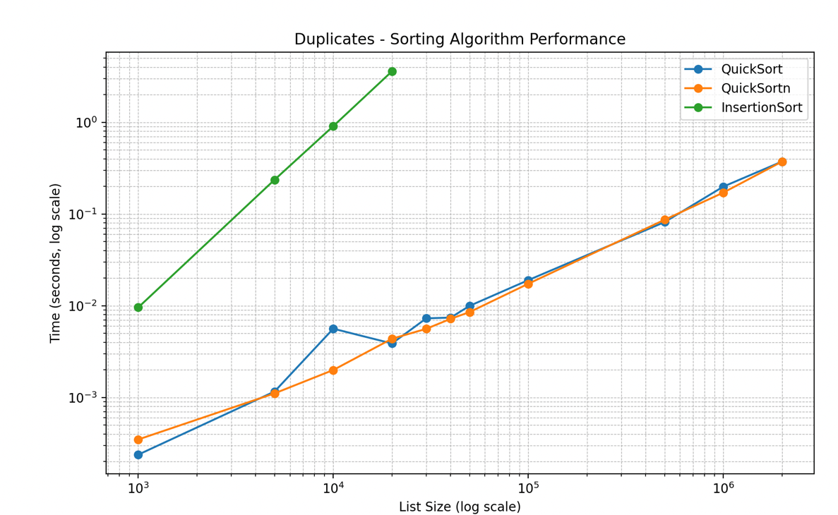
Figure 1important one
Although the improved version does not seem faster, it is about the same speed and is much more consistent. As can be seen the original version had major changes in time during this duplicates benchmark, while the new and improved version stayed very consistent.
